Object oriented Programming
Practical Assignment 8
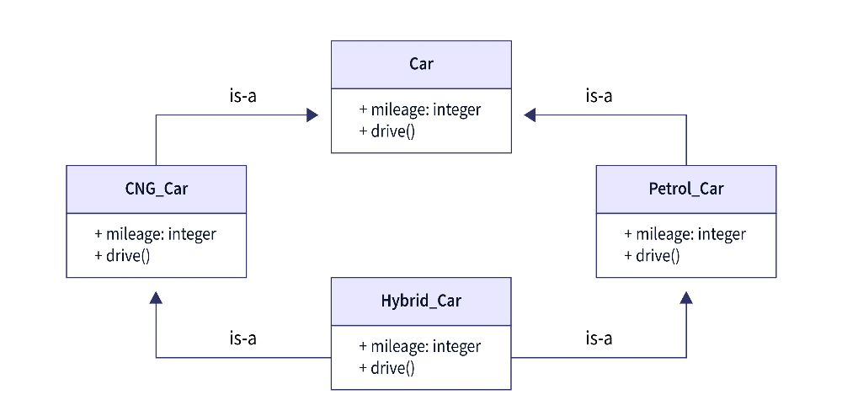

Explain what’s wrong in the above diagram. How it can be solved? Implement the solution.
package Interface;

interface car{
int mileage=35;
}
interface petrol_car extends car{
int mileage=35;
public void drive();
}
interface CNG_car extends car{
int mileage=35;
public void drive();
}
class hybrid_car implements CNG_car,petrol_car{
int mileage=151;
public void drive(){
System.out.println("hybrid car mileage : "+mileage);
}
}
public class interface_or_2 {

public static void main(String[] args) {
// TODO code application logic here
hybrid_car obj1=new hybrid_car();
obj1.drive();
}

}
Output:
hybrid car mileage : 151
BUILD SUCCESSFUL (total time: 0 seconds)

